YOUR DOCUMENT ON LEXTENSO.FR - 08/03/2019 11:30 | ISABELLE MARTIN / ORDER OF LAWYERS
https://www.fichier-pdf.fr/2019/03/22/fichier-pdf-sans-nom-5/fichier-pdf-sans-nom.pdf

Ehlers-Danlos and false accusations of abuse

From Gazette du Palais - n ° 09- page 19 Date of publication: 05/03 / 2019Id: GPL343y8Ref: Gas. Pal. March 5, 2019, No. 343y8, p. 19

Ehler-Danlos disease still too often leads to conclusions of parental violence, where medical expertise should systematically seek parenteral, where medical expertise should

It may seem strange that a frequent disease whose incidence is at least 2% in France and 3% in Belgium1, continues to be ignored by the vast majority of doctors, 147 years after its first description, in Moscow, by Tschernogobov2 and 118 years after his re-description by Ehlers3, in 1900, in Copenhagen

This lack of knowledge leads to iatrogenic accidents due to hemorrhages under anticoagulation treatment or colonic perforation by colonoscopy. It is also at the origin of medico-legal problems: unjustified accusations of parental mistreatment or ignorance of the effects of accidental trauma of the public or labor way aggravating a previous state of fragility not compensated by the responsible person.

The absence of reliable genetic tests in a hereditary disease that is transmitted to all children, at least one of whom is at least four, has become an obstacle to diagnosis. These patients are victims of generalization, both for physicians and patients, of the idea that in the absence of a biological test or imaging, the diagnosis is not possible. However, in Ehlers-Danlos's disease, clinical criteria of certainty are available because of a significant grouping of signs whose validity has been demonstrated recently by mathematical modeling5

The very important role accorded to parental violence is probably at the root of the increase in false accusations6 with unjustified withdrawal of children from their parents with dangerous medical consequences by the non-supervision of a fragile child exposed to complications, especially abdominal complications.

To this must be added a false prejudice of benignity, the consequence of inadequate historical descriptions7, the effects of which still wipe out doctors. Elsewhere, in front of the multiplicity of symptoms, it is a psychosomatic interpretation or a psychiatrisation, summed up by the too infamous famous: "it is in the head", "go see a psychologist or ... a psychiatrist", "take you in charge "," do not complain all the time ".

Update of clinical data on Ehlers-Danlos disease. Ehlers-Danlos disease is an inherited disorder of the connective tissue, that is to say that it affects all the tissues of the human body, except for the brain and the nervous system. The clinical manifestations result from two consequences: the fragility responsible for hemorrhages, difficulties of healing, spontaneous fractures, and the variability of the signals sent by the sensors implanted in tissues with modified mechanical characteristics responsible for alterations of the perception of the body and of his environment.

The comparison of a population of 853 patients with 826 healthy subjects has established a mathematical model8 according to which five signs in a list of nine are sufficient to confirm the diagnosis with a 1/5

- diffuse articular and periarticular pain,
- severe fatigue,
- disturbances of the control of the voluntary movements, with clumsiness, hurdles of obstacles, deviation of lamarche, falls
- joint instability with pseudo sprains, blockages, subluxations (including crunches) or dislocations;
- a skin thinned, transparent, stretchable, not protecting against electrostatism
- joint hypermobility, the absence of which does not exclude the diagnosis;
- gastroesophageal reflux;
- bruising, for minimal trauma
- hyperacusis

Other signs may be associated: neuro-vegetative, digestive, hypersensoriality cutaneous and olfactory, insomnia, dystonia, metrorrhagia, shortness of breath, diplopia, dental fragility ... Cognitive disorders are common, anxiety, emotion, autistic spectrum. These clinical arguments are reinforced by the observation of identical familial cases, proof of the hereditary nature of this disease.

Moderate shock bruise

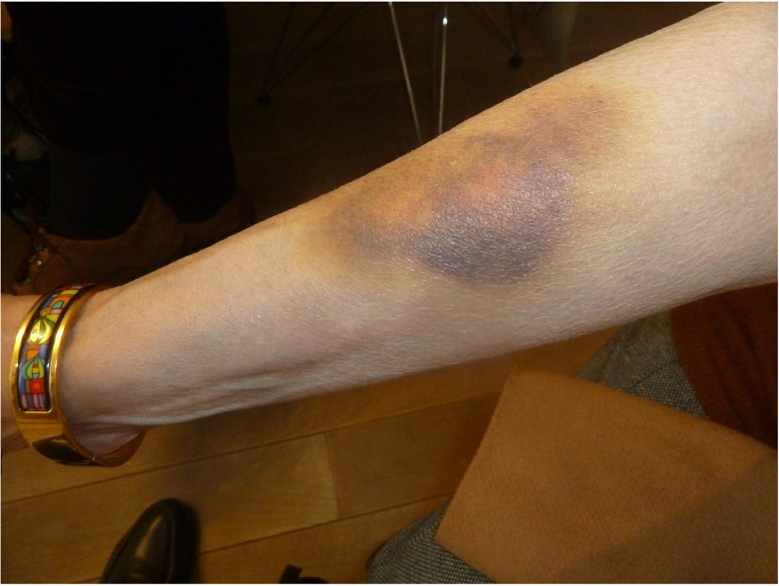

Hypermobility of the joints

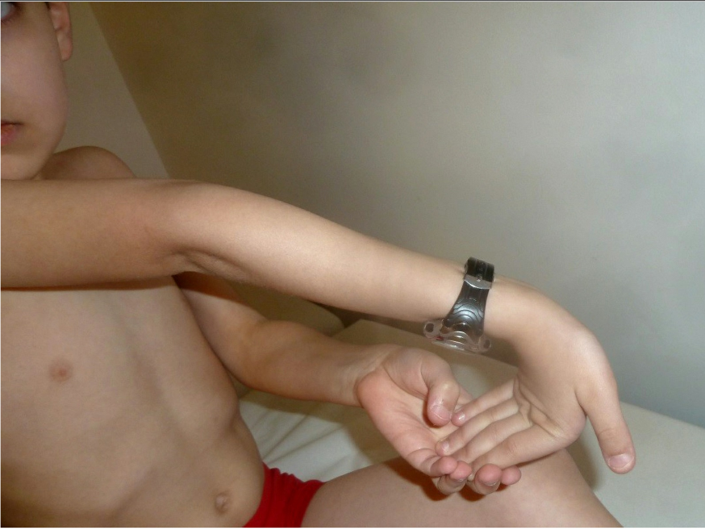

The confusion with the syndrome of the beaten children or the "shaken baby".
Silverman is the name of the neuroradiologist, author of the description in 1953 of fractures discovered in the young child that is attributed to the syndrome of the beaten children. This is the most important medico-legal problem faced by parents and their child (ren) with Ehlers-Danlos disease. The emotional and social consequences for unjustly accused parents, when at least one of them is affected by the same illness, is considerable. Consequences for the child, separated from his family are also serious, for his health because he risks complications that can put his life at stake by being entrusted to a host family unaware of its fragilities.

The reasons for this confusion are the discovery of bruises or other bleeding, wounds, fractures, most often without displacement, which can sit at the bony ends but also at the ribs, the skull ..., deluxations. Reporting to the courts is often done by pediatric emergencies, often without informing and questioning parents.

The "shaken baby" syndrome was the subject of a joint statement by the Haute Autorité de Santé (HAS) and the French Society of Physical Medicine and Rehabilitation (SOFMER) in 20179. It is responsible for cerebral haemorrhagic lesions observed as well. in Ehlers-Danlos disease

Discussion. Ehlers-Danlos's disease is never mentioned by the experts in the face of these accusations of violence. That is why we have made a detailed description of it so that it appears in all the missions to experts about a parental violence. Unjustly suspecting parents is not without consequence for the doctor himself. Some families have lodged complaints against doctors who have not made the diagnosis. Health and medical ethics officials must be aware of this reality.
In the United States, Michael Holick from Boston University has done a great deal of expertise with Ehlers-Danlos disease and parents accused of violence. He attributes fractures to bone fragility, vitamin D deficiency, increased in the first months of life.

"Spontaneous" microfractures, without violence, in an infant with
1 -Ehlers-Danlosune disease m

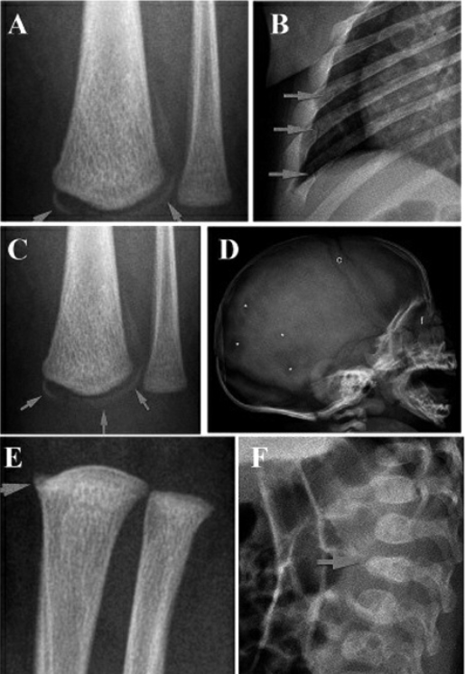

Pictures provided by Dr. Michel Holick

It is important that the doctor who suspects Silverman Syndrome or the "shaken baby" has made sure to eliminate another cause. The high frequency of Ehlers-Danlos disease requires that it be evoked systematically. Other diseases may be criminalized such as "glass bone disease". The family character highlighted by the discovery of signs in one parent is a very strong argument.

Beyond the accusations of violence, there are other medico-legal contexts in which ignorance of the Ehlers-Danlos disease diagnosis can lead to errors. This is the case of disagreements between spouses. Due to the frequent psychiatricization of symptoms by doctors, one of the spouses, the spouse most often, "accuses" the other of mental disorders. This argument is also used to deny custody of children, incase of divorce.

Conclusions. Before considering parental violence, the doctor and the judge must, in front of a child presenting lesions evoking this hypothesis, systematically discuss the presence of a very common but very poorly known inherited disease: Ehlers-Danlos

FOOTNOTES

- Hamonet Cl., Manicourt D., Hermanns-Lê T. et Pommeret S., « Clinical diagnosis of Ehlers-Danlos syndrome.New fundamental insights into the clinical seeing », International symposium on the Ehlers-Danlos syndrome,26-29 sept. 2018, Ghent (Belgium).
- Chernogobov N.A., "On a case of Cutis laxa", presentation at the first meeting of MoscowDermatologic and Venerologic Society, 13 nov 1891, in Monatshefte for practical dermatology, 1892, Hamburg, 14: 76.
- Ehlers E., "Cutis laxa. Tendency to Haemorrhagia in the Skin, Lockering of Multiple Articulations », Dermatologische Zeitschrift 1901, 8: 173-174.
- Hamonet Cl., Manicourt D., Hermanns-Lê T. et Pommeret S., « Clinical diagnosis of Ehlers-Danlos syndrome.New fundamental insights into the clinical seeing », International symposium on the Ehlers-Danlos syndrome,26-29 sept. 2018, Ghent (Belgium).
- Hamonet Cl., Brissot R., Gompel A., Baeza-Velasco C., Guinchat V., Brock I., Ducret L., Pommeret S. etMetlaine A., « Ehlers-Danlos Syndrome (EDS) – Contribution to Clinical Diagnosis – A Prospective Study of853 Patients », EC Neurology 2018, 10.6
- Hamonet Cl., "Suspicion of parents - do not confuse abuse and Ehlers-Danlos syndrome", The Physician's Daily, 24 Nov. 2009.
- Hamonet Cl., Ducret L., Baeza-Velasco C and Layadi K., "Ehlers-Danlos-Tschernogoubov - Tense History of a Disease", in History of Medical Sciences, 2016, vol. L, no. 1, p. 29
- Hamonet Cl., Brock I., Pommeret S., Amoretti R., Baeza-Velasco C. and Metlaine A., "Ehlers-Danlos syndrome (EDS) type III (hypermobile): validation of a somatosensory clinical scale ( ECSS-62), about 626 cases, Bull. Acad. Nat. Med. 2017, 201, No. 1-2-3, 405-415, meeting of Feb. 28, 2017; Hamonet C1., Brissot R., Gompel A., Baeza-Velasco C., Guinchat V., Brock I., Ducret L., Pommeret S. and Metlaine A., "Ehlers-DanlosSyndrome (EDS) - Contribution to Clinical Diagnosis - A Prospective Study of 853 Patients ", EC Neurology 2018,10.6.
- HAS, Service of Good Professional Practice and SOFMER, June. 2017
- Holick M.L., Hossein-Nezhad, Tabatabaei F., « Multiple fractures in infants who have Ehlers-Danlos/hypermobility syndrome and or vitamin D deficiency. A case series of 72 infants whose parents wereaccused of child abuse and neglect », Dermato-Endocrinology 2017, vol. 9, issue 1 7.

From Gazette du Palais - n ° 09- page 19 Date of publication: 05/03 / 2019Id: GPL343y8Ref: Gas. Pal. March 5, 2019, No. 343y8, p. 19

Authors: Claude Hamonet, Former Certified Expert at the Court of Cassation, Professor Emeritus, University Paris-Est-Créteil (UPEC), Ehlers-Danlos Consultation, Center of Deprivation and Diagnosis Ellasanté, Marie Jouvencel, Expert at the Court of Appeal of Versailles, Daniel Manicourt, Department of Rheumatology, Ehers-Danlos Syndrome, Saint-Luc University Clinics in Brussels (Belgium), Michael Holick, Department of Medicine, University of Boston Hospital (USA)

